Korea Advanced Institute of Science and Technology

School of Electrical Engineering

EE488 Introduction to Machine Learning Spring 2018

Name: Dinh Vu

Student ID: 20184187

**Assignment 1 (Problem 5)**

**Perceptron & SVM Algorithm (Matlab Programming Assignment)**

1. **Implementing Perceptron Algorithm**

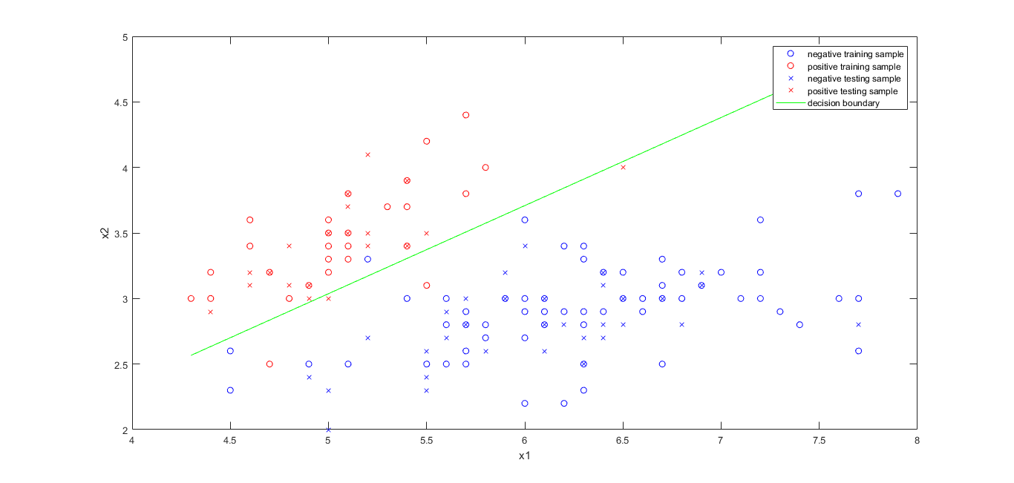

**Figure 5.1.** The decision boundary of Perceptron algorithm

In my code, to achieve the highest accuracy 96.4%, I choose the learning rate is 0.1 and the number of iterations is 10.

Using Perceptron cannot get the 100% accuracy because the training data is not linear separable.

1. **Implementing Soft-SVM using SGD**

The decision boundary found by using Soft-SVM is shown in the Figure 5.2, 5.3, 5.4, 5.5 with the number of iterations is 10000 and λ = 0.1.

In each different time executing Soft-SVM, the accuracy is varied because in line 16 of train.m file the index sample is chosen randomly by the uniform distribution. However, for the number of iterations very large such as 10000, the accuracy always higher than 94 % even reach 100% as displayed in Figure 5.2.

The disadvantage of this Soft-SVM is that one training data sample could be chosen randomly at many time of iteration if the number of iteration is not great enough.

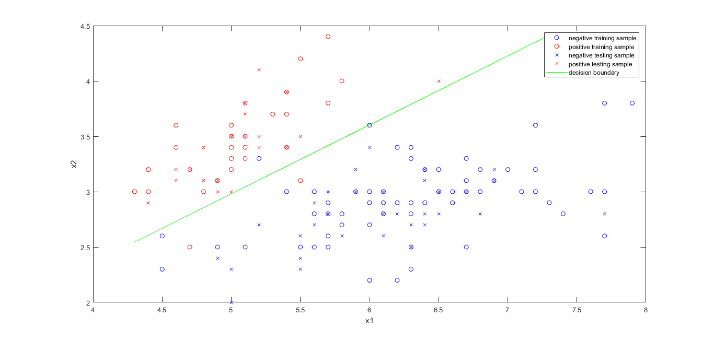

**Figure 5.2.** The decision boundary of Soft-SVM using SGD with acc = 100%

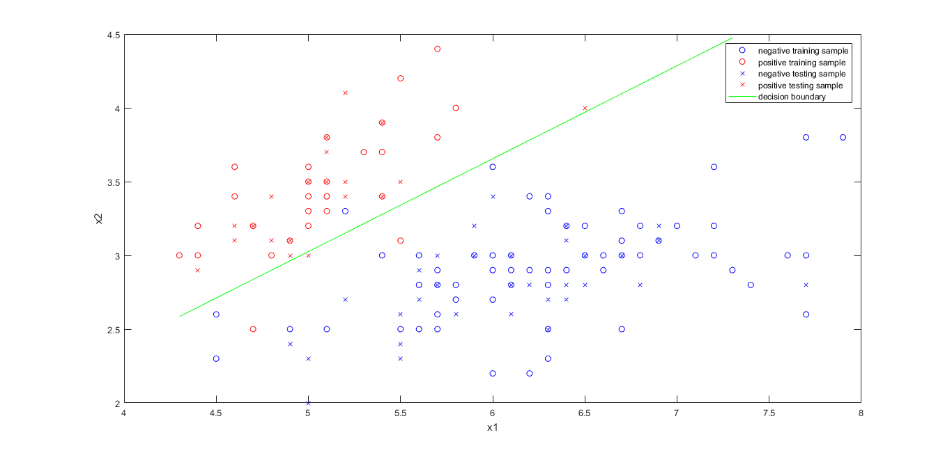

**Figure 5.3.** The decision boundary of Soft-SVM using SGD with acc = 98.2%

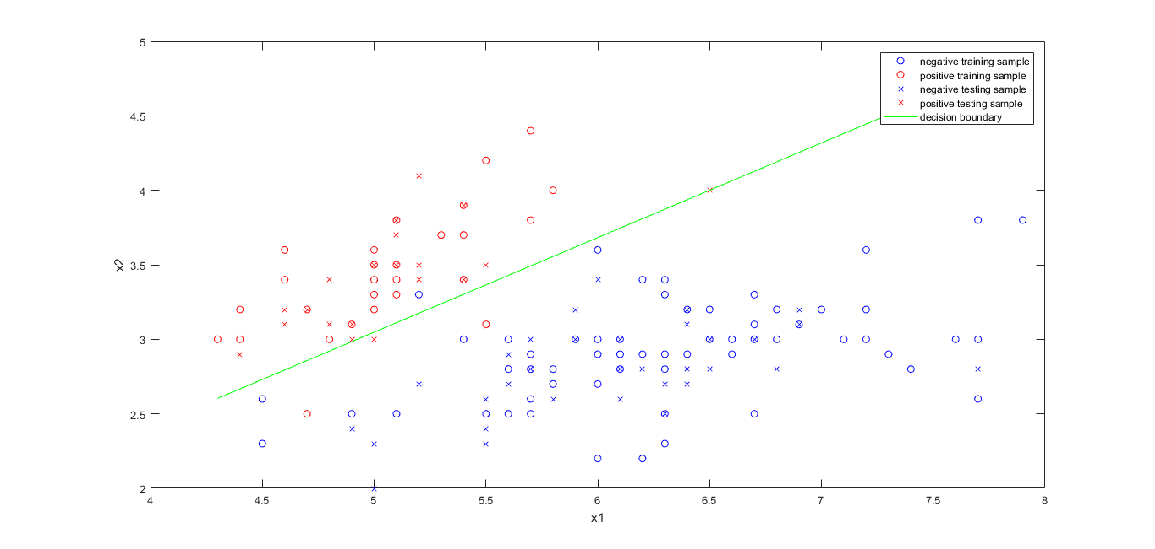

**Figure 5.4.** The decision boundary of Soft-SVM using SGD with acc = 96.4%

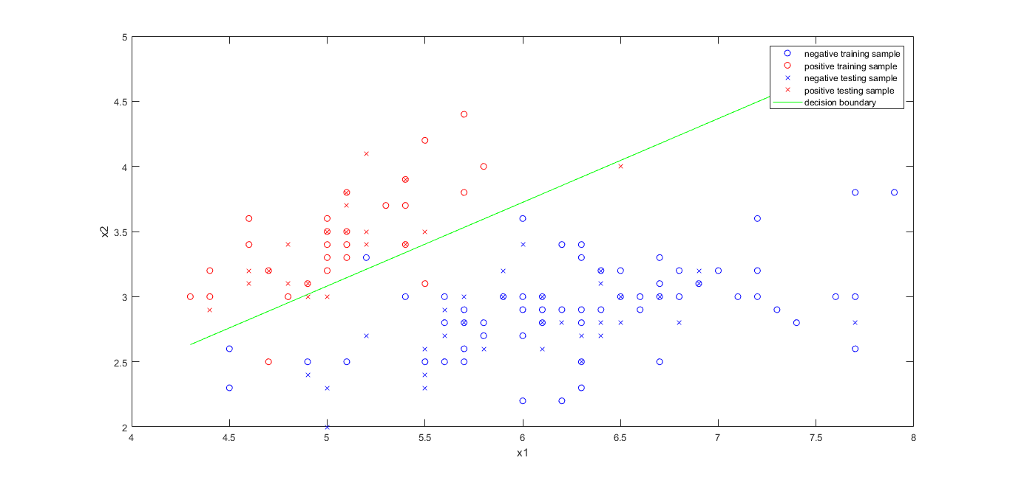

**Figure 5.5.** The decision boundary of Soft-SVM using SGD with acc = 94.6%